TDT4205 Compiler Construction
Assignment/Problem Statement 5

Eirik Lie Morken
May 3, 2019

1 Theory 30%

1.1 Part I

Create control flow graphs for the following program fragments:

1. for ( a ; b ; c) d ; e;
2. a ; while ( b ) d ; c ; e ;
3. a ; do d ; c ; while ( b ); e ;

1. Control flow graph for program fragment 1.

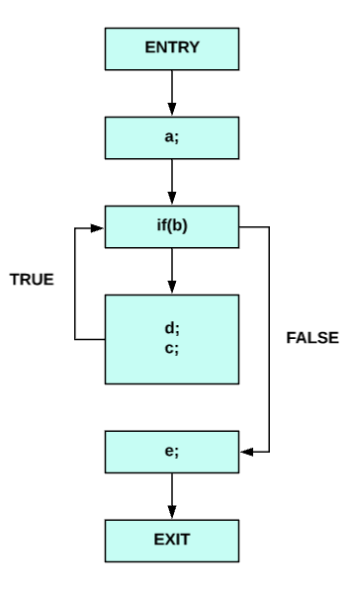
for ( a ; b ; c) d ; e;

2. Control flow graph for program fragment 2.

a ; while ( b ) d ; c ; e ;
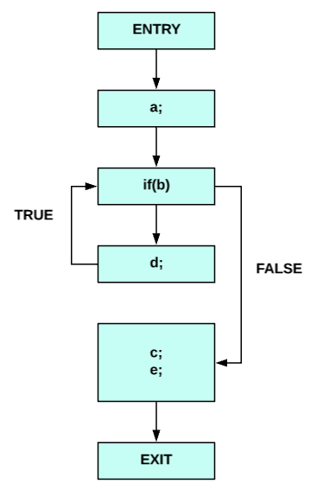

3. Control flow graph for program fragment 3.

a ; do d ; c ; while ( b ); e ;
